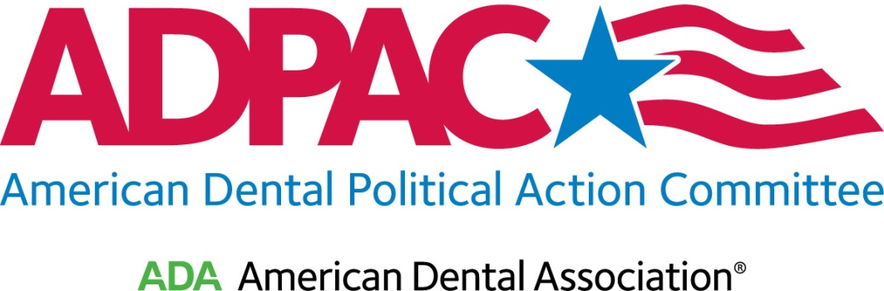

STUDENT MEMBERSHIP FORM

ADA Member Number is Required for ADPAC Membership

(PLEASE PRINT CLEARLY)
Name

School
ADA Member Number (Required for Membership)

Mailing Address

City, State, Zip

Phone

E-mail

- Please check here if you would like your e-mail address added to the Grassroots Alert Network.
CONTRIBUTION:
- $5 – Basic Member | - $7.50 – Basic Member and Spouse
- $50 – Capital Club Member | - $75 – Capital Club Member and Spouse
Spouse Name: ________________________________________________________________

- Check enclosed (made out to ADPAC)
- Please charge my (circle one) VISA/MC/AMEX
# Exp. Date
Signature

Contributions to ADPAC are strictly voluntary and are not deductible for federal income tax purposes. Federal law requires political committees to report the name, mailing address, occupation and name of employer for each individual whose contributions aggregate in excess of $200 in a calendar year. If you need additional information, please contact us at 202-898-2410 or pontzern@ada.org.

AMERICAN DENTAL POLITICAL ACTION COMMITTEE
1111 14th Street, NW, Suite 1100; Washington, DC 20005

