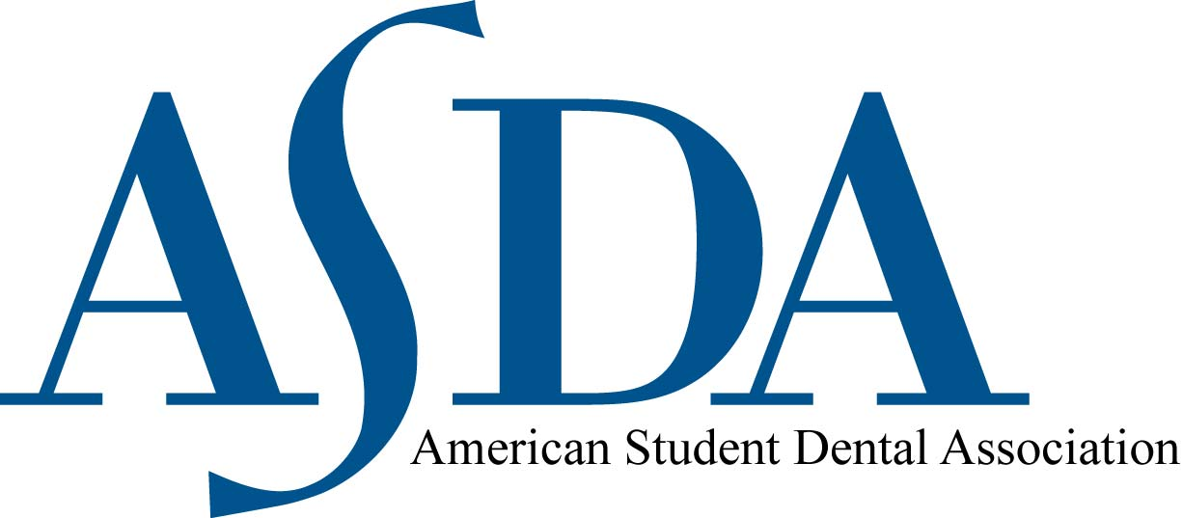

Dear Future Colleague:

Congratulations on your acceptance to SCHOOL NAME. You should be proud of your choice to attend one of the best dental schools in the nation! Not only will you become part of one of the finest health educational institutions in the world, you will become a member of the SCHOOL NAME family. We look forward to meeting you.

I would like to take a moment to introduce you to the American Student Dental Association (ASDA). ASDA is the nation’s largest student-run association for dental students. ASDA is the only national association entirely devoted to student concerns and the student viewpoint on professional issues, representing more than 22,000 students attending U.S. dental schools. At CHAPTER, our student organization aims for active involvement in local, state, and national issues affecting dental students and the profession as a whole. As an ASDA member, you also receive automatic membership into the ADA.

As an ASDA member you become part of your ASDA chapter, district and the national organization. You have the opportunity to develop your dental community, meet dental students from around the country, develop leadership skills, become published, and advocate for legislative priorities of importance to dental students such as licensure reform and student debt. Plus, membership provides you access to publications, the opportunity to activate free life and disability insurance, discounts on automobile insurance and office supplies. Your $93 membership fee is paid only once each year. Your ASDA/ADA membership is a worthwhile investment in your career. It combines your single voice with those of your professional student colleagues to create a more powerful statement of your views. This $93 is an investment in your own future.

The CHAPTER NAME…(provide info on chapter activities, leadership opportunities, and benefits).

For more detailed information about the benefits of ASDA, visit ASDA’s website at www.ASDAnet.org. Please also contact me by email at any time if you have any questions about your membership in ASDA. I will be more than willing to help.

We look forward to having you join us.

Sincerely,

CHAPTER President
EMAIL ADDRESS

